2020
Wood Mountain Regional Park Board
Revised
11/29/2020
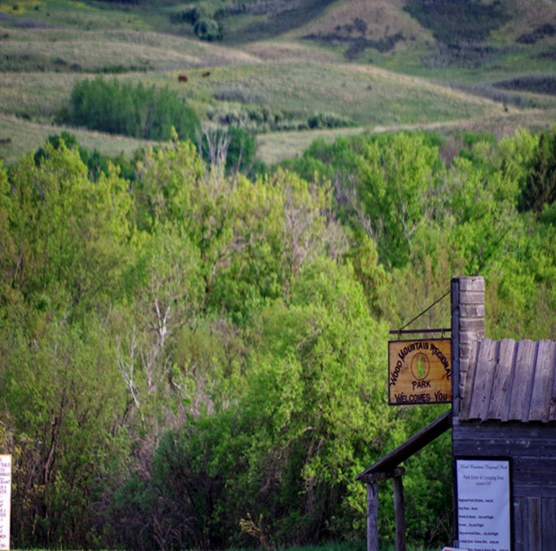
WOOD MOUNTAIN REGIONAL PARK POLICIES AND PROCEDURES
WOOD MOUNTIAN REGIONAL PARK
POLICIES AND PROCEDURES
Revised 2020

TABLE OF CONTENTS

I. Board of Directors
A) Elected Officials
B) Conflict of Interest
C) Responsibility and Structure of the Park Board

II. Personnel
A) Employment Levels
B) Employment Selection
C) Pay Scale
D) Work Environment
E) Corrective Discipline
1) Grounds for Disciplinary Action
2) Disciplinary Guidelines
3)Grounds for Immediate Dismissal
4)Dismissal Guidelines

III. Organizational
A) Rules and Regulations of the Park
B) Park, Camping and Swimming and Rental fees

IV. Emergency Procedures
A) Important Information
B) Emergency Measures

V. Definitions

I. BOARD OF DIRECTORS

A) Elected Officials

1) Set forth how the official Park Board of Directors is established
(i.e. RM’s, Villages, Towns – appointed etc.)

2) This Board of Directors has then appointed the” Working Committee”. This committee will assume all the board responsibilities with respect to the overall sound operational practices and will herein be referred to as the “Park Board”
This “Park Board” will consist of one Board of Directors, along with volunteers, whose term of office will be staggered as follows:

4 positions held for 3-year terms with the option to extend

3) A Quorum shall then be the members of the “Park Board” (working committee), who attend a regular scheduled or special called meeting.

4) The working committee shall keep minutes of its proceedings.

B. Conflict of Interest

1) Each Park Board member shall declare a potential conflict of interest and will not be involved in the decision-making process in which they hold a direct or personal interest in:
- The hiring of immediate family
- The tendering of services
They must excuse themselves from the process and such shall be noted
In the minutes.

C. Responsibility and Structure of the Board

1) Annual meeting will be held within 3 months of the fiscal year end of the Park (Dec 31).

2) Notice of the annual meeting must be posted in local Media (posters, social media, etc.) 2 weeks prior to the meeting.

3) Copies of the yearly financial statements must be provided to all in attendance of annual meeting with the option to email attendees.

4) Selection of competent management and staff.

5) Review and maintain policies annually to ensure they are current and relevant.

II. PERSONNEL

A. Employment Levels

1) It is policy of the Wood Mountain Regional Park to provide a job description for the Park Manager(s).

2) For the purpose of clarification, the following levels of employment shall be recognized:
2.1 Full-time- employees who are engaged in permanent
employment but works a pre-determined schedule, 40
hrs/week.
2.2 Permanent Part-time- employees who work less than 40
week but work on a pre-determined work schedule.
2.3 Casual- employees who work on an as needed basis, with a
minimum 4-hour shift.
2.4 Term Contract- a contract agreement for a specified term and
purpose that outlines terms and conditions.

B. Employment Selection

1) Employment applications of immediate family members of the board will be given the same consideration as all other applicants.

2) Refer to Conflict of Interest Clause Section B point 1.

3) RCMP background check on all supervisory positions.

4) Valid drivers license for all full and part-time maintenance workers that require to drive Park vehicles.

C. Pay Scale

1) Manager Pay is a monthly wage. Wage is dependant on experience.

2) Pay Scale for Maintenance Workers is as follows:
2.1 Senior Maintenance: Minimum wage + $2
2.2 Part-time Maintenance: Minimum wage + $1
2.3 Maintenance staff will receive an additional $.50/ year of
experience to a max of $2.
3) Pay Scale for Lifeguards is as follows:
3.1 Junior Lifeguard Minimum: Wage + $1
3.2 Lifeguard or Instructor: Minimum Wage + $2
3.3 Lifeguard & Instructor: Minimum Wage + $3
3.4 Head Lifeguard: Minimum Wage + $4
3.5 Pool staff will receive an additional $.50/ year of experience to a
Mx of $2.
D. Work Environment

1) All employees will be allowed camping in the designated area only.
The designated area is west of the number sites (1-14). All underage employees must have their parent’s signature on the “Parental Responsibility” form to camp in the Park.

2) The only personnel allowed in the designated staff camping area at any time are staff and immediate family members.

3) Any worker failing to adhere to proper standards of conduct and Park rules will be given ONE WARNING. This warning will be noted in their employee file and the “Park Board” will be notified. A second offence will result in employment TERMINATION.

4) All workers will be constantly evaluated. Their work schedule will be determined by their performance and their status may be changed at any time.

5) If for any reason a worker can not come to work when requested, this will be considered TIME-OFF. The Park will not be expected to make up these hours.

6) Any workers concerns should be addressed to the workers immediate supervisor.
6.1 Park Maintenance Employee will report to Park Manager.
6.1 Pool Employees will report to Pool Manager or Pool Board
Member.

7) All issues or concerns should be logged, and resolution noted. If for any
reason the issue can not be resolved at this level, then it is brought before the Park Board for resolution.

8) Park Manager is to bring logbook to Park meetings.

9) Employees who work 6 hours or more shall have an unpaid meal break for ½ an hour within every 5 consecutive hours of work.

10) Employees will be given two 15-minute paid breaks each 8-hour shift.

E. Corrective Discipline
Employees and Contract Workers will be subject to corrective actions for, but not limited to the following:

1) Grounds for Disciplinary Action
The following infractions, which workers are always expected to avoid, are not intended to be all inclusive of the required disciplines or proper standards of conduct.
1.1 Excessive tardiness.
1.2 Abuse of allowable break time or time away from work area.
1.3 Use of foul or abusive language in the park.
1.4 Loitering, sleeping on the job, or deliberately taking more time than
it should, to preform a duty.
1.5 Receiving an excessive number of personal visitors, phones calls
(messages) or conducting personal business during scheduled
working hours.
1.6 Improper or indecent conduct on Park premises.
1.7 Unauthorized use of Park tools, equipment, or facilities.
1.8 Unnecessary use or waste of Park supplies.
1.9 Unsatisfactory performance of duties or failure to follow any Park
policy or procedure.
1.10 Failure to report injuries, property damage or report any condition
which may result in future injury or property damage.
1.11 Restricting or interfering with the performance of other
employees’ duties as well as engaging or participating in any
interruption of work.
1.12 Conduct which would subject the Wood Mountain Regional Park
disgrace or loss of reputation.

2) Disciplinary Guidelines
Failure to adhere to the above will result in one logged warning and upon a second infraction, termination at the discretion of the Park Board.

3) Grounds for Immediate Dismissal
The following infractions, which workers are always expected to avoid are not intended to be inclusive of the required disciplines or proper standards of conduct.

3.1 Falsification of employment application and/or timesheets.
3.2 Damage or defacing Park property.
3.3 Under the influence of drugs or intoxicating beverages during
working hours in the Park.
3.4 Fighting on the Park premises.
3.5 Insubordination to supervisor, refusal to preform supervisors’
assignments, or directing abusive or threatening language at any
Board Member, Park worker or Patron.
3.6 Possession of illegal weapons not required for work in the Park.
3.7 Stealing property from the Park, Booth, Museum, Rodeo Club or
Patrons of the Park.

4) Dismissal Guidelines
Failure to adhere to the above will result in termination at discretion of the Park Board.

III. ORGANIZATIONAL

A) Rules and Regulations of the Park

1. Park entrance gates are open from 7am- 11pm except for special events, whereby they are extended at the discretion of the Park Manager.
2. Quiet time – 11pm
3. Fires in designated fire rings only.
4. Speed limit within the Park is 20km/hr
5. Legal guardian (18 years of age +) must sign camp registration and is responsible for all damages.
6. NO OPEN LIQUOR beyond designated campsites and picnic areas.
7. Pets are welcome but must remain on leash, all droppings must be picked up by the owner and disposed of in sealed bags.
8. All motorized vehicles must be operated by someone with a valid driver’s license.
9. No camping in Sleeping Hollow.
10. The Park is not responsible for lost, stolen or damaged items.

Failure to adhere to Park rules:

1. ONE WARNING in the form of a letter.
2. EXPULSION and possible FINE at the discretion of the Park Board.

B) Park, Camping and Swimming Fees. Rentals

Park Fees:
Daily Entrance $10
Regional Park Season Pass $50
30 Amp Power and Water $40/night or $800/4 weeks or $1500/season
15 Amp Power $30/night or $600/4 weeks or $1100/season
Nonservice Site $20/night

Pool Fees:
Child (0-2) free
Youth (3-12) $6
Adult (13+) $10
1-week Single Pass $50
1- week Family Pass $100
Season Single Pass $100
Season Family Pass $250
Single Weekend Pass $25
Family Weekend Pass $50

Lesson Fees:
Parent and Tots $40
Preschool 1-5 $50
Swimmer 1-6 $60
Rookie/Ranger/Star $75
Bronze Medallion $200
Bronze Cross $200

Rental Fees:
Summer Kitchen $25/day
Hall $150/day
Hall $50/meeting
Propane Griddle $25
BK’s Booth Rental $75
Concession Booth $750/year

IV EMERGENCY PROCEDURES

A) Important information
1) In case of emergency call 911

2) Nearest EMS:
a. Fire - Wood Mountain Village
b. Ambulance – Assiniboia – ETA 48 mins.
c. Police – Assiniboia – ETA 48 mins.

3) Land Location – NW 20-4-3 W3M RM #43

B) Emergency Measures

1) In case of emergency Muster Point is the Pool Parking Lot

2) In case of tornado all Patrons and staff should gather in the Pool House.

V DEFINITIONS

1. Worker - any individual that receives payment for services
rendered.

2. Immediate Family - spouse, common law and children in the same household.

3. Legal Guardian - parent or adult 18+ years of age.

4. Insubordination - disobedient to authority.

5. Disobedient - refusing or neglecting to obey or listen.

